

**Placement Empowerment Program**

***Cloud Computing and DevOps Centre***

Deploy your static website using Github Pages : Host your local Git repository’s static website directly using Github pages

Name: MADHHUMETHRA AP Department: IT



**Introduction**

GitHub Pages is a static site hosting service designed to publish your projects directly from a GitHub repository. It allows developers to showcase their work, create personal websites, or host documentation in an efficient, free, and straightforward way.

### **Overview**

## Automates deployment of static website changes

## Updates server whenever changes are pushed

## Simplifies deployment process, reducing manual effort and errors

**Objectives**

## Deploy a static website using GitHub Pages, hosting a local Git repository's static website directly.

**Importance**

## Hosting a static website on GitHub Pages is important because:

## 1. Easy deployment: Simplifies the deployment process, reducing manual effort and errors.

## 2. Free hosting: Provides free hosting for static websites, reducing costs.

## 3. Version control: Integrates with GitHub version control, allowing for easy tracking of changes

## .4. Customizable: Offers customizable themes and layouts, enabling personalized branding.

## 5. Fast and reliable: GitHub Pages provides fast and reliable hosting, ensuring high uptime and performance.

**Step-by-Step Overview**

**Step 1**

### Create a New Repository: Once you're logged in, click the green "New" button on the top right of your GitHub homepage to create a new repository. Give your repository a name, for example, my-static-website. Leave the other settings as default, and click "Create repository "

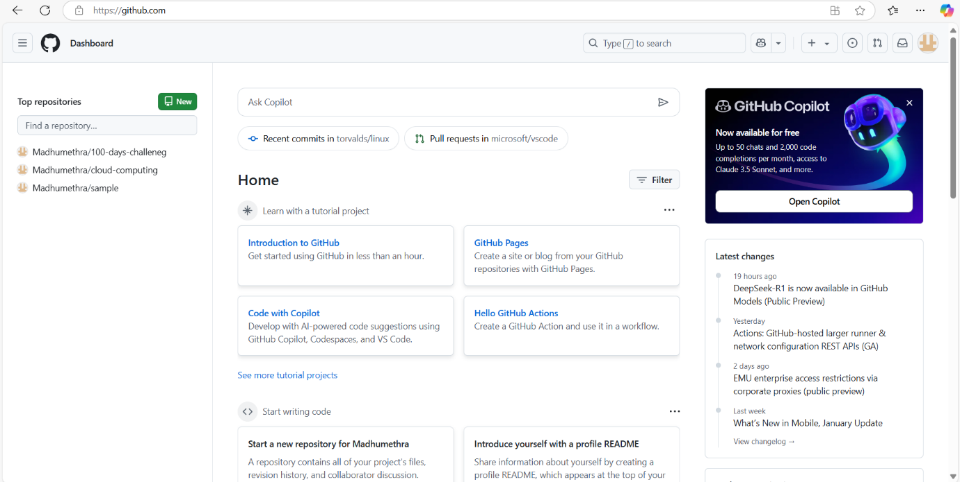

**Step 2**

## Create a folder (e.g., my-static-website) where you’ll keep all your website files. Inside that folder, create the main file for your website, called index.html. Here’s a simple example of what to put in your index.html

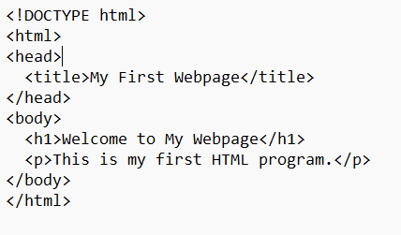

**Step 3**

## Open Command Prompt and navigate to the folder where your index.html file is saved. Use the cd command to navigate

**Step 4**

## Initialize a Git repository by running

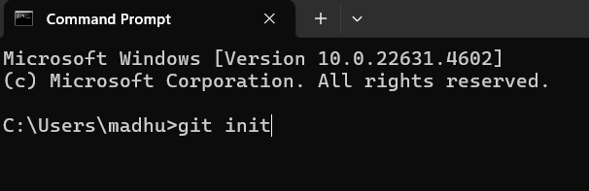

**Step 5**

## Add your website files to the repository

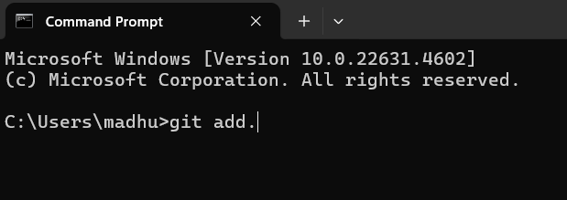

**Step 6**

## Save the changes in Git with a commit message

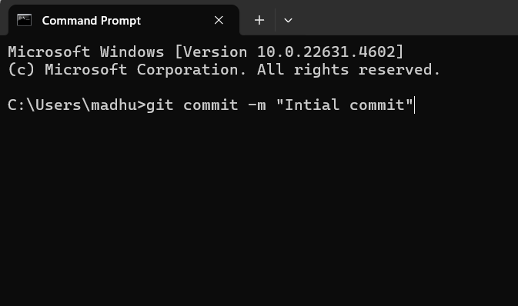

**Step 7**

## Access Your Website Wait a few minutes for GitHub Pages to deploy your site

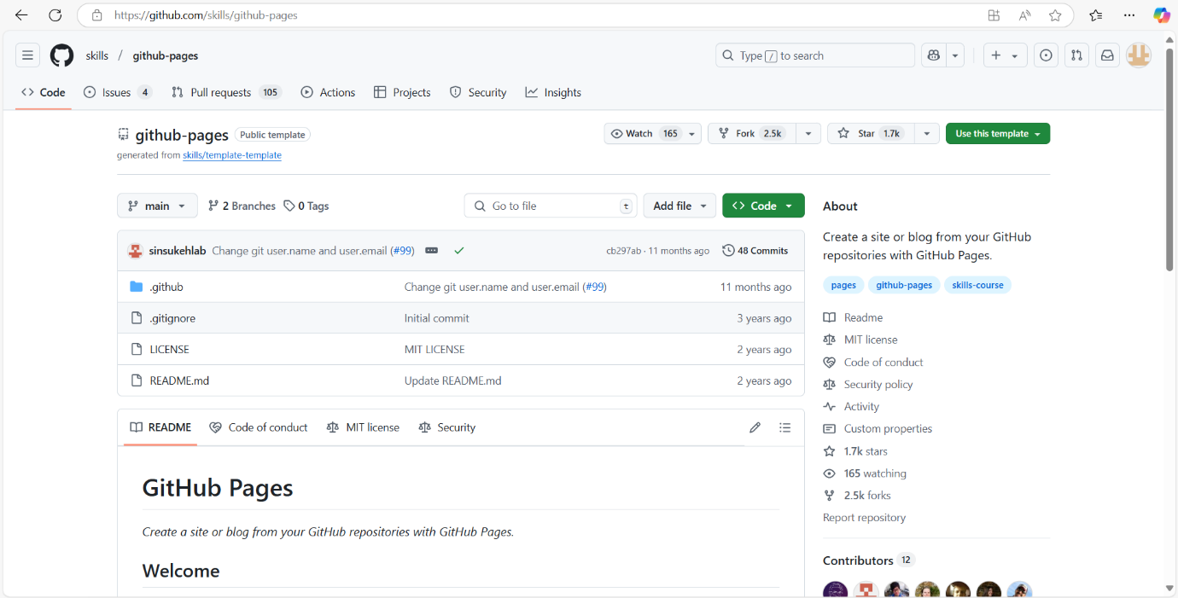

**Output**

## 1. Live website: A publicly accessible website showcasing content.

## 2. Automated deployment: Changes to the website are automatically deployed.

## 3. Version control: Changes are tracked and managed through GitHub.

## 4. Customizable: Website appearance and layout can be easily customized.

## 5. Reliable hosting: Website is hosted on a fast and reliable platform.